**Paper Title for JIEAS**

**Name Surname1*, Name Surname2**

**1**Department of Arts, University of Arts, Tirana, Albania

2 Department of Social Science, University of Tirana, Albania

* **Corresponding Author**: email:

**Abstract**

AMEA Publisher in Albania publishes an open access peer reviewed international journal named “Journal of Arts and Humanities Science (JAHS) ISSN: (Online)" is an open access journal which means that all content is freely available without charge to the user or his/her institution. Users are allowed to read, download, copy, distribute, print, search, or link to the full texts of the articles, or use them for any other lawful purpose, without asking prior permission from the publisher or the author. JAHS also charges zero submission and processing fees for contributors. In this way, anyone can freely submit articles for review and potential publication. This is in accordance with the DOAJ and BOAI definition of open access.

***Keywords:*** Introduction; text layout; results and discussion; conclusion; references.

1. **Introduction**

Manuscript shall be formatted for an A4 size page. The left and right margins shall be 30 mm. The bottom and top margin shall be 25 mm. The text shall have both the left and right margins justified. The manuscript should be organized in the following order: title of the paper, authors' names and affiliation, abstract, keywords, nomenclature (where applicable), introduction, body of the paper (in sequential headings), conclusion, acknowledgement, references, and appendices (where applicable). The title is centred on the page and is set in boldface with 14 pt font size. The first letter of each word in the title should be capitalized. It should adequately describe the content of the paper. An abbreviated title of less than 60 characters (including spaces) should also be suggested.

The author's name(s) follows the title but with different size and is also centred on the page (font size 12 pt). Last names should be spelled out in full and succeeded by author's initials. The author's affiliation, and e-mail address (all in font size 11 pt) are provided below. It should be an abbreviated, accurate presentation of the contents of the paper. The abstract should contain sufficient information to enable readers to decide whether they should obtain and read the entire paper. Do not cite references in the abstract. The author should provide a list of three to six key words that clearly describe the subject matter of the paper.

1. **Text Layout**

The manuscript must be typed in single spacing. Use extra line spacing between equations, illustrations, figures and tables. The body of the text should be prepared using Times New Roman. The font size used for preparation of the manuscript must be 12 points. The first paragraph following a heading should not be indented. The following paragraphs must be indented 12.7 mm. Note that there is no line spacing between paragraphs unless a subheading is used. Symbols for physical quantities in the text should be written in *italics*.Section headings should be numbered and typed left align on the page and in capital letters only. The type, fonts and style above (Times New Roman 12 point bold) are an example of a section heading. Do not underline section headings. A bold font should be used for section headings.

**2.1 Section Headings**

Subheadings should be positioned at the left margin and numbered following the heading, in a bold-faced font the same size as the main text (Times New Roman 12 point) with single line spacing above and below. The first letter of each word in the subheading should be capitalized.

*2.1.1 Sub-subheadings*

Sub-subheadings should be numbered and typed using same as heading but font the same size as that used for the body of the text (Times New Roman 12-point italics). Only the first letter in the subheading should be capitalized. Note that a blank line precedes and follows thesubheading.

**2.2 Equations and Mathematical Expressions**

Equation numbers should appear in parentheses and be numbered consecutively. All equation numbers must appear on the right-hand side of the equation and should be referred to within the text. Two different types of styles can be used for equations and mathematical expressions. They are:

1. In-line style $x*e*QC$
2. Display style.

*2.2.1 In-line style*

In-line equations/expressions are embedded in paragraphs of the text. For example, E = mc2. In-line equations should not be numbered.

*2.2.2 Display style*

Equations in display format are separated from the paragraphs of text. They should be flushed to the left of the column as shown in Eq. (1). Fractional powers should be used instead of root signs. A slash (/) should be used instead of a horizontal line for fractions, whenever possible; for example, use 2/3 for two-thirds. Refer to equations in the text as " Eq.(1)" or, if at the beginning of a sentence, as " Equation (1)". Vectors should be typed boldface. Do not use arrows, wavy-line underscoring, etc. The use of SI units is strongly recommended, and mixed units are to be avoided.

|  |  |
| --- | --- |
|  | (1) |

**2.3 Figure and Table**

Figures (diagrams and photographs) should be numbered consecutively using Latin numbers. They should be placed in the text soon after the point where they are referenced. Figures should be centred in a column and should have a figure caption placed underneath as shown in Figure 1. Captions should be centred in the column, in the format “Figure 1” and are in upper and lowercase letters. When referring to a figure in the body of the text, the abbreviation "Figure" is used Illustrations must be submitted in digital format, with a good resolution.

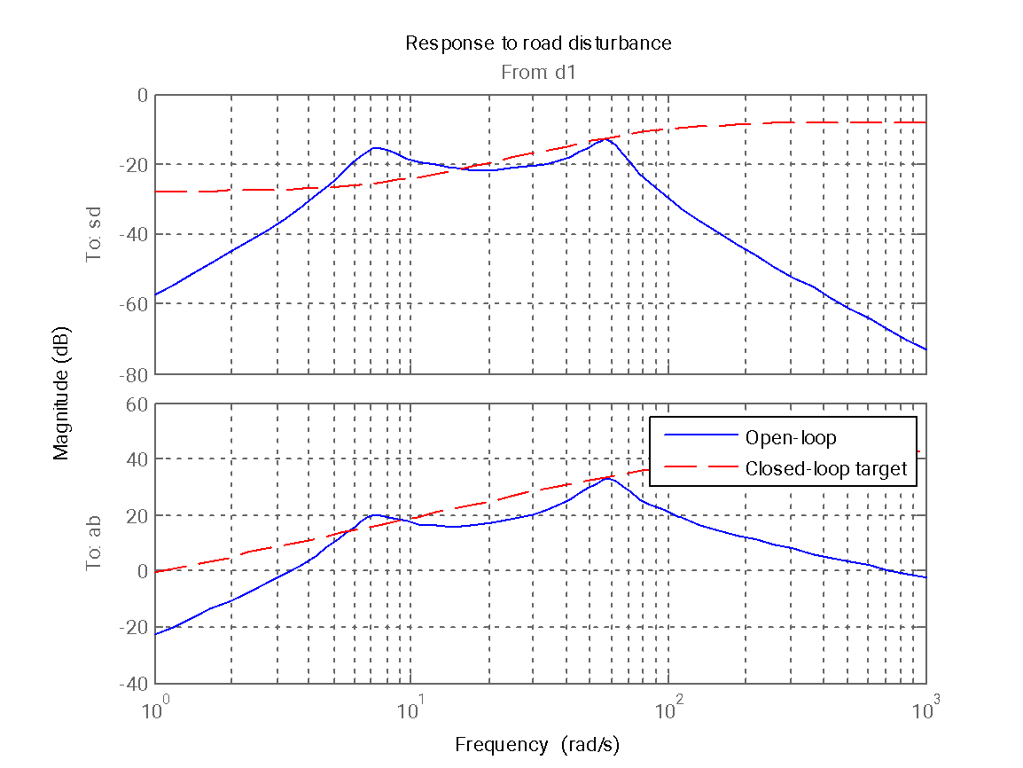

Figure 1. Figure format.

Table captions appear centred above the table in upper and lowercase letters. When referring to a table in the text, "Table" with the proper number is used. Captions should be centred in the column, in the format “Table 1” and are in upper and lowercase letters as shown in Table 1. Tables are numbered consecutively and independently of any figures. All figures and tables must be incorporated into the text (in portrait orientation).

Table 1. Table format.

|  |  |  |
| --- | --- | --- |
| Column number 1 | Column number 2 | Column number 3 |
| Parameter 1 (N) | 12.3 | 1.5 |
| Parameter 2 (kg) | 34.50 | 12.00 |
| Parameter 3 (mm) | 25 | 9 |

1. **Conclusion**

A conclusion section must be included and should indicate clearly the advantages, limitations and possible applications of the paper. Discuss about future work.

An acknowledgement section may be presented after the conclusion, if desired. Individuals or units other than authors who were of direct help in the work could be acknowledged by a brief statement following the text.

**Acknowledgement**

This study is supported or funded by Project EURO123456 from the European Union’s Programme. The authors would like to thank Univeristy of Arts for supporting this research project.

**Conflict of interests**

The authors would like to confirm that there is no conflict of interests associated with this publication and there is no financial fund for this work that can affect the research outcomes.

**Reference Formatting**

In general, JIEAS follows IEEE format for reference. It’s highly recommended to use EndNote or Mendeley for citation. There are strict requirements on reference formatting at submission stage. Author should be preparing references according to following examples and the reference style should be consistent where applicable, author(s) name(s), journal title/book title, chapter title/article title, year of publication, volume number/book chapter and the pagination must be present. Use of DOI is highly encouraged. The reference style used by the journal will be also applied to the accepted article at the proof stage. Note that missing data will be highlighted at proof stage for the author to correct.

**Citation in Text**

Document your study throughout the text by indicates references by number(s) in square brackets (Example; Shehu and Tusha [1]; Shehu [2]; Shehu et al. [3]…) in line with the text. The actual authors can be referred to, but the reference number(s) must always be given.

**Reference List**

Number the references (numbers should be in square brackets) in the reference list in the order to they appeared in the text. List of references indents 6 mm from the second line of each reference. Personal communications and unpublished data are not acceptable references. Example of desired references are as following.

(We would like to encourage authors to cite 2 to 4 papers which published in JIEAS journal and related to your article)

**References**

1. Kim H. and Ryu J. Sideslip Angle Estimation Considering Short-duration Longitudinal Velocity Variation, *International Journal of Automotive Technology*, 2011; 12(4); 545-553.
2. Hac A., Nichols D. and Sygnarowicz D. Estimation of Vehicle Roll Angle and Side Slip for Crash Sensing, *SAE International Congress*, 2010; 1; 1-11.
3. Lenain R., Thuilot B., Cariou Ch. and Martinet P. Mixed Kinematic and Dynamic sideslip angle Observer for accurate Control of Fast Off-road Mobile Robots, *Journal of Field Robotics*, 2010; 27(2); 181-196.
4. Minh V.T. *Advanced Vehicle Dynamics*, 1st edition, Malaya Press, Pantai Valley, 50603. Kuala Lumpur, Malaysia.
5. Ackermann J. and Sienel W. Robust Yaw Damping of Cars with Front and Rear Wheel Steering", *IEEE Transactions on Control Systems Technology*, 1993; 1(1); 15-20.
6. Minh V.T., Moezzi R., Cyrus J. and Dhoska K. Smart Mechatronic Elbow Brace using EMG Sensors. *International Journal of Innovative Technology and Interdisciplinary Sciences*, 2022; 5(2); 865-873.
7. Minh V.T., Katushin N., Moezzi R., Dhoska K. and Pumwa J. Smart Glove for Augmented and Virtual Reality. *International Journal of Innovative Technology and Interdisciplinary Sciences*, 2021; 4(2); 663-671.

**Cite this article as**: Dhoska I., Adami E. Paper Title JAHS, *Journal of Arts and Humanities Science*. 2024; 1(1); xxx-xxx.